PCB Journal

Day 1
The first day started with designing and calculating the SMPS with the DC/DC converter. This was done in Proteus and each component was calculated using relevant data from the datasheet.
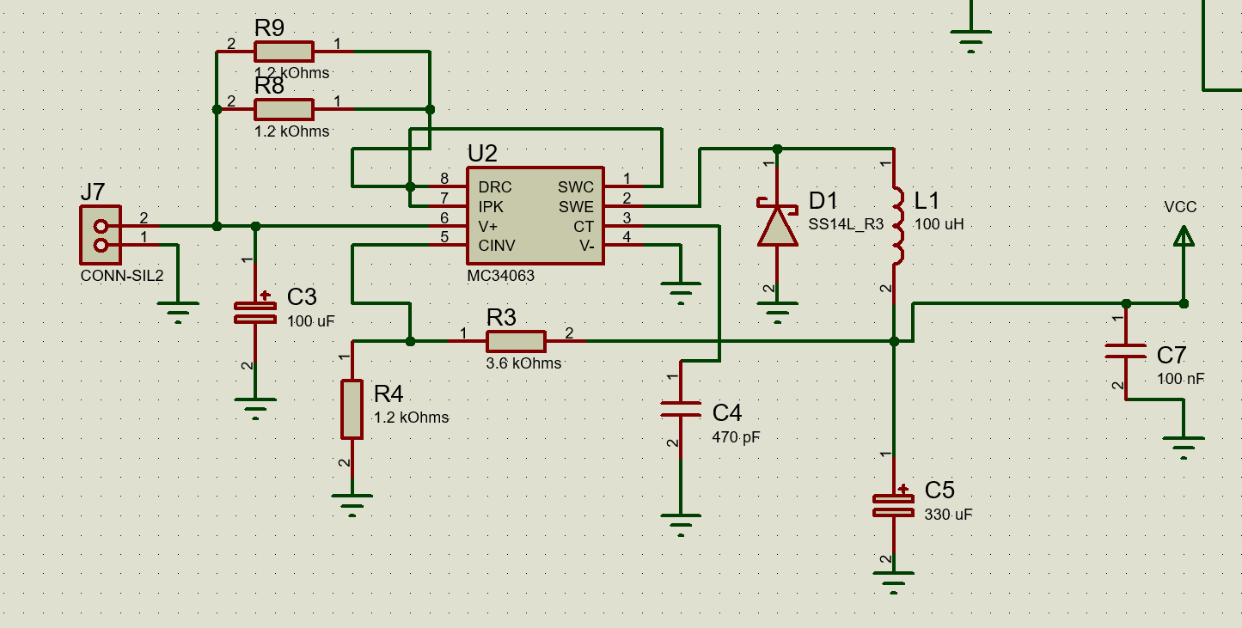
After the raw schematic was done, taking inspiration from the SMPS assignment, I started calculating the necessary Voltage.
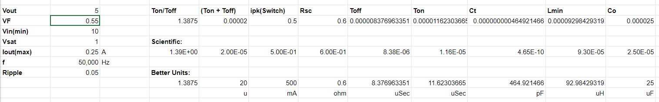
None of the components were calculated since a staple had been created in the class where everybody was using the same DC/DC converter, diode and inductor. The rest of the values remained stock to the SMPS assignment.

Day 2
On day two the rest of the schematic was completed. The pinout and the ATmega 1284 microcontroller were wired and decoupling capacitors were also added to the schematic; completing the schematic.
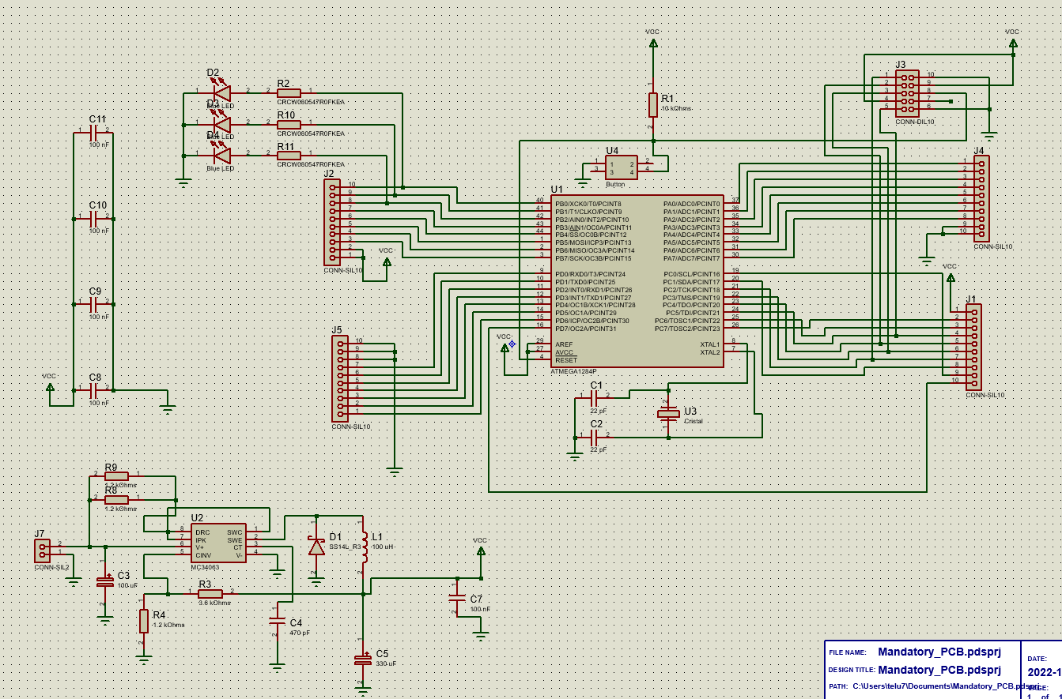

Day 3
On the third day work started on the PCB layout using the components selected in the schematic. All of the components had to be changed from the previously made since all of the values were changed manually and did not match the products name. All of the components had to be SMD as well. After changing that the PDB layout schematic was created. At first the PCB was created with 4 parallel pinouts in order to save on size and material but that was later changed to a dual parallel pinout design.
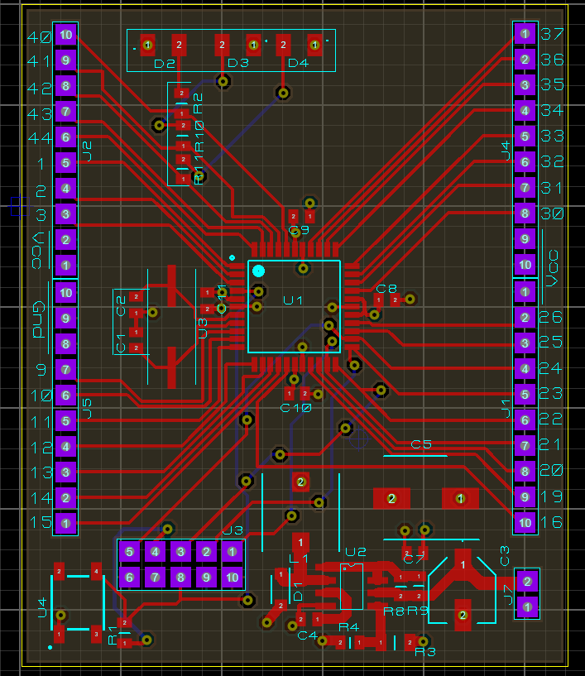
This concluded day three as the hardware needed to complete the assignment was missing.

Day 4
On day four we received the necessary hardware to assemble the PCB. First the DC/DC converter was soldered along with all of the necessary adjacent components. After being tested using a Power Supply and a Voltmeter I noticed that 0Vwere making it to the pins so I started testing different components but the problem was not solved.
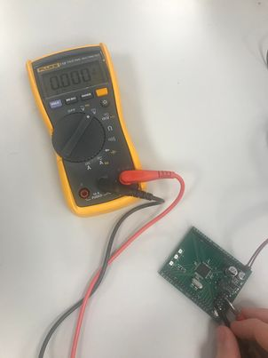.

Day 5
On the last day of the assignment I have decided to solder everything needed for the PCB and continue testing the DC/DC converter. During development a few pins were damaged and a VIA was ripped off the PCB, this did not represent an impediment as I could use the other side of the VIA to solder the pins.
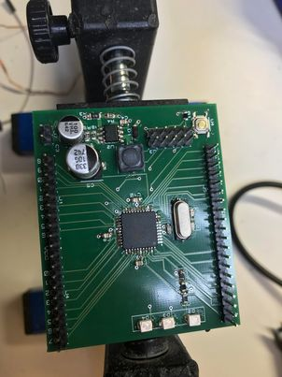
After the PCB was completed I resumed troubleshooting the DC/DC converter. I tried every component's voltage, I double checked that everything is in the correct order and in the correct orientation. I tried fluctuating the power from 8.5 V to 14.4 V but still no voltage could be read on the PCBs 5V pin. Nothing seemed to fix the problem and everything that I tested seemed to work fine.

Conclusion
I was unable to make the PCB work due to an unknown issue with the DC/DC converter. It was very hard to solder everything together and I did manage to damage the board multiple times.

